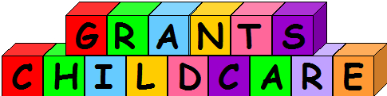

Address: Grant’s Childcare, 75 Alfred Street, Gloucester, Gloucestershire, GL1 4BU
 07931 451 566  www.grants-childcare.co.uk  grant@grants-childcare.co.uk

Medical Care, Personal Care, First-Aid & Medications Policy – Adapted 01/02/2012

At times children may need to receive medical intervention, first-aid or medications administered.

By signing the consent form you agree to the following;

Medical Care:
As a childcarer specializing in working with children with complex/additional needs I accept that at times I may need to perform medical procedures, such as but not limited to giving a feed via PEG. As the child’s parent/carer you must accept full responsibility for ensuring that I am trained and competent to perform a procedure. Should a child require medical care by another practitioner and you are unreachable you authorize me to act in absolute loco-parentis, giving me authority to give consent and sign for necessary treatment.

Personal Care:
You give me full authority to undertake personal care tasks for your child as deemed necessary. You will provide me with appropriate, equipment, items and facilities to undertake these tasks.

First-Aid
For the purpose of this policy First-Aid encompasses both injury and illness, chronic and acute. You authorize me, Grant Harman to undertake appropriate diagnostic tests and treat as I see fit in the best interests of your child.

Medications:
You authorize me, Grant Harman to give medications as prescribed by a healthcare professional or bought by yourself over the counter. You take full responsibility for informing me of any allergies your child may have. Should your child need any medication that is not on their consent form, I am happy to give this providing you provide in writing the drug, when it is to be given, the dosage, the route of administration and sign and date at the bottom. In the case of drugs such as paracetamol and ibuprofen you may add these to the consent form labeled as PRN or as required. You accept full responsibility for informing me if your child has had a dose of one of these drugs in the last 48 hours, when and how much and understand the consequences of not doing so and accepting responsibility for these.

